IMPLEMENT LINEAR REGRESSION

AIM
To implement Simple Linear Regression using Python to predict students' marks based on the number of hours studied and evaluate the model using Mean Squared Error (MSE) and R² Score.

ALGORITHM
- Import the required libraries: Pandas, Matplotlib, train_test_split, LinearRegression, mean_squared_error, and r2_score.
- Load the dataset from the CSV file data.csv.
- Select Hours_Studied as the input feature XX.
- Select Marks as the target variable yy.
- Split the dataset into training and testing sets using an 80:20 ratio with random_state=42.
- Create a Linear Regression model using LinearRegression().
- Train the model using fit() with the training data.
- Predict the marks for the test data using predict().
- Evaluate the model using Mean Squared Error and R² Score.
- Display the predicted marks.
- Plot the actual data points and regression line using Matplotlib.
- Label the axes, add a title and legend, and display the graph using plt.show().
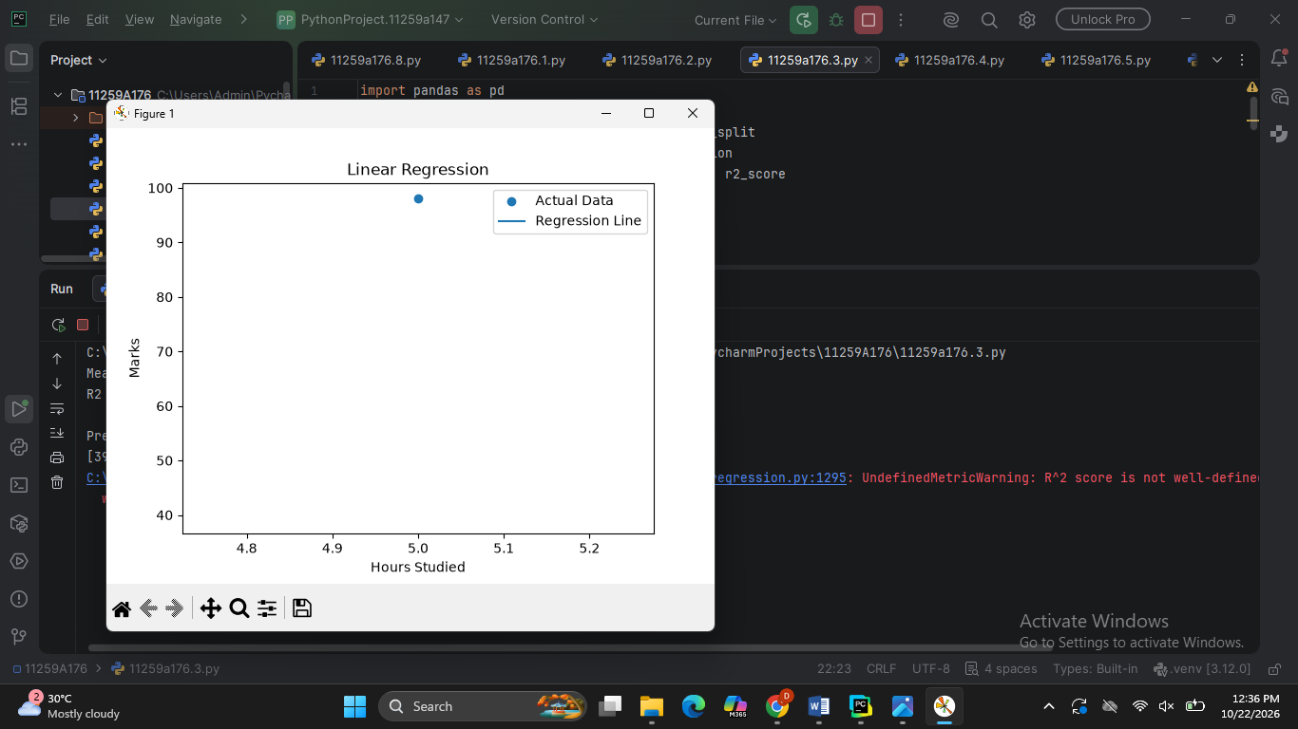
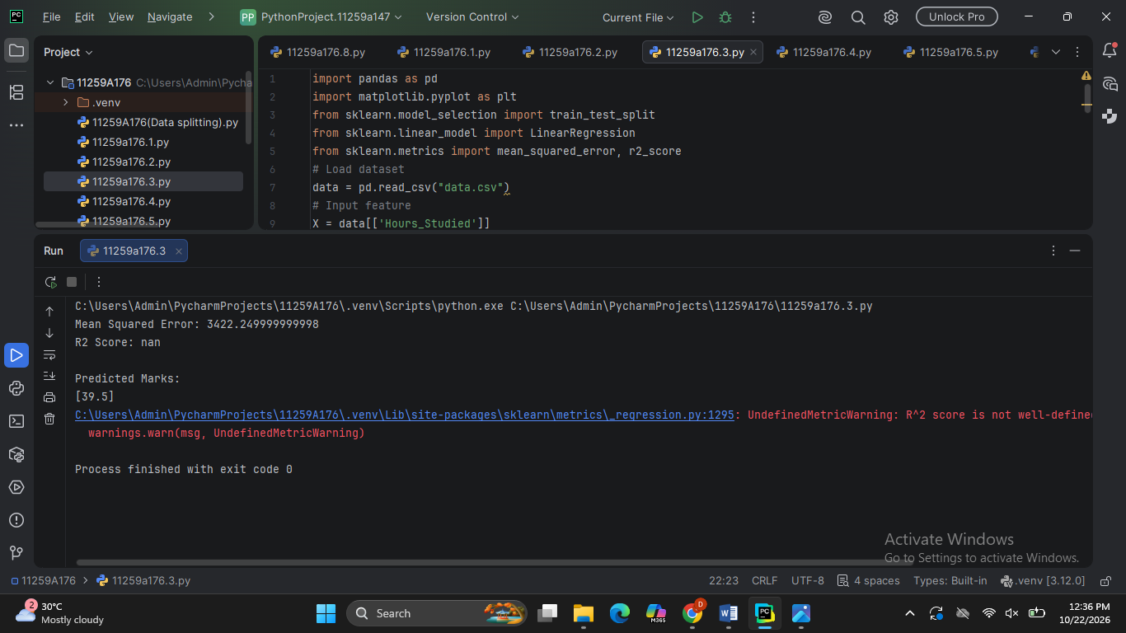

RESULT
The Simple Linear Regression model was trained successfully to predict students' marks based on hours studied. The model's performance was evaluated using Mean Squared Error (MSE) and R² Score. The predicted marks were displayed, and a graph showing the actual data points and the regression line was plotted.

